**Plugin: Interactive Geo Maps**

Step 1 : Download and add plugins in the project

Step 2 : Activate the plugins and add the license key.

# Add/Edit Map

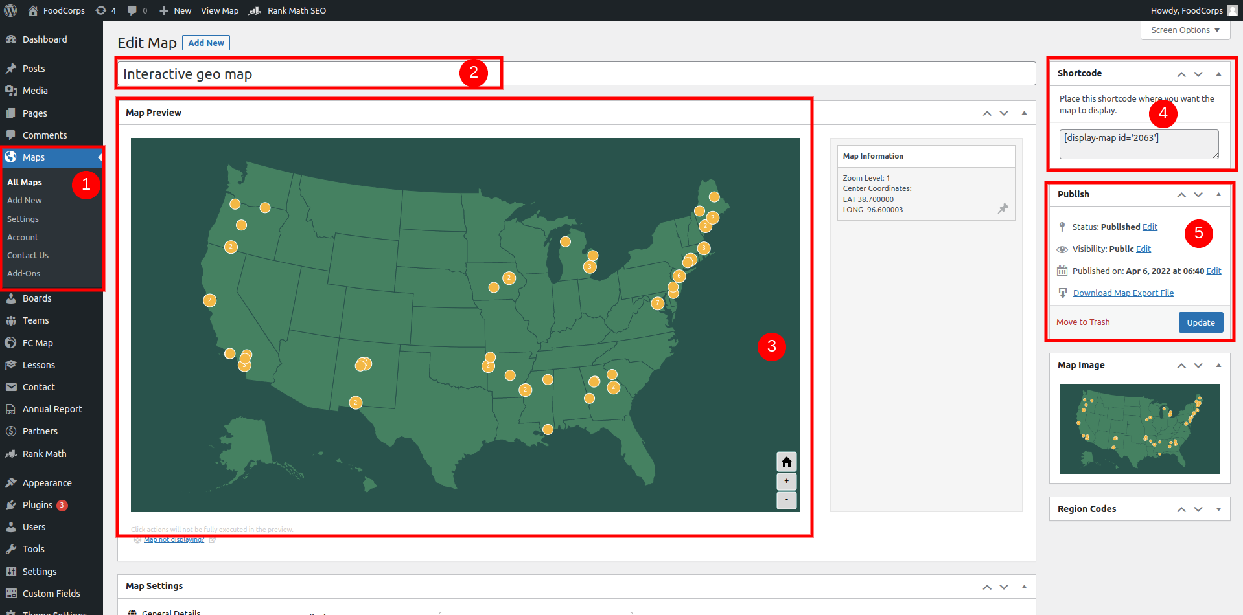

1. Add/Edit new map form the left menu section
2. You can add/ edit the name of the map
3. Map view in frontend
4. Copy these shortcode and paste them into the page where you want to show this page.
5. Save the changes you have made

# Map Settings

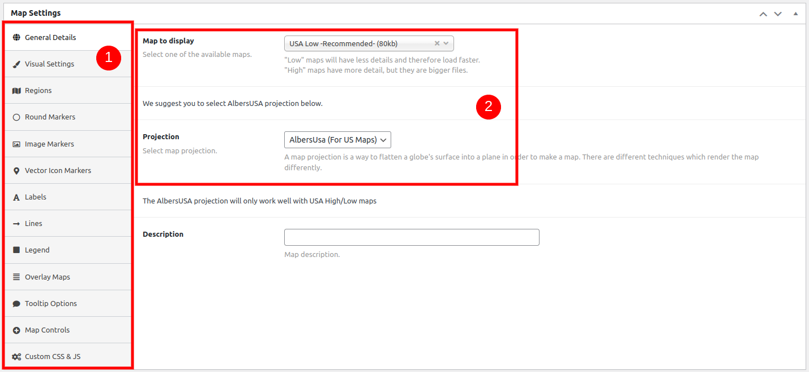

1. Change settings as per your need on the left hand side menu
2. Change the map display form the select options

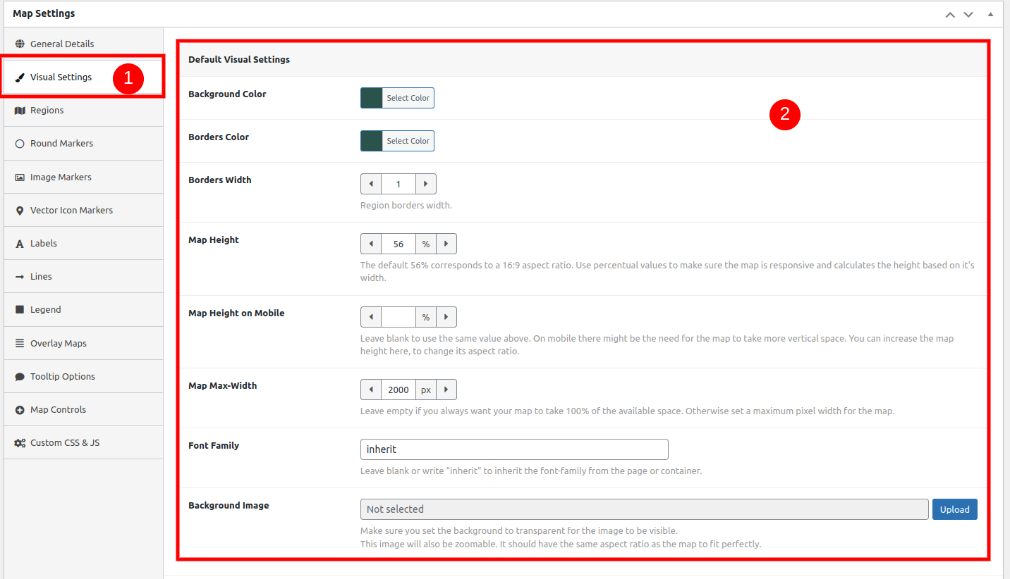

1. Click on visual settings to change the map color and border color
2. Change the map color and settings

# Add Marker

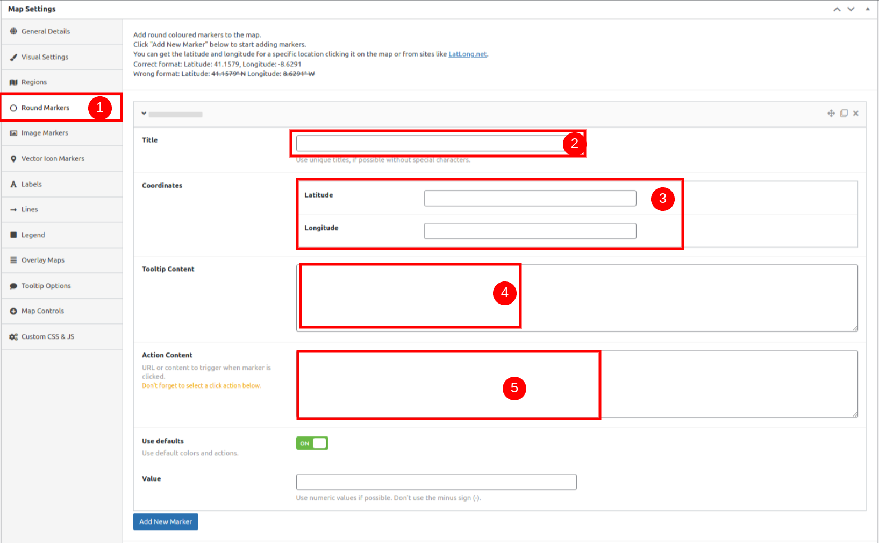

1. Select on round markers to add marker
2. Add title of the marker
3. Add latitude and longitude
4. Add tooltip content
5. Add action content

Action content is displayed in popup, you can see in below screenshot

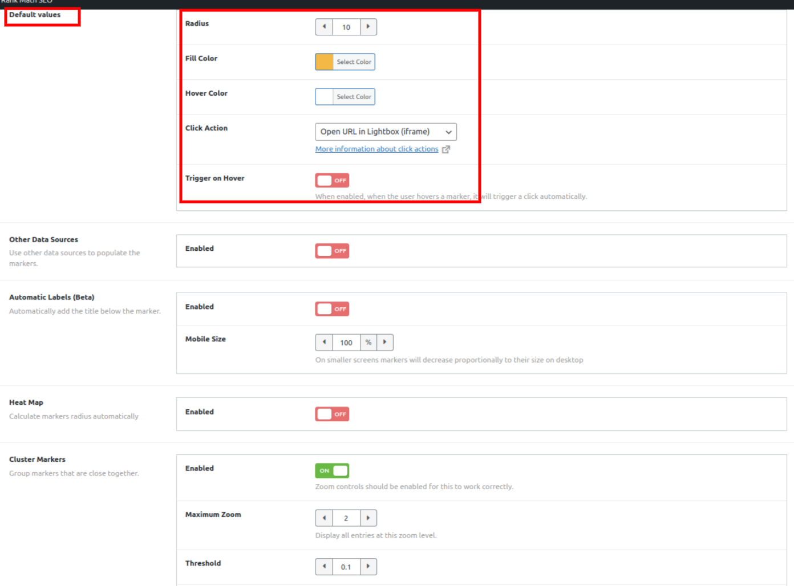

* Change default value of the marker. Change color, radius
* On click action select option you can choose the option where to show the **action content** of the map.

# Add Marker from spreadsheet

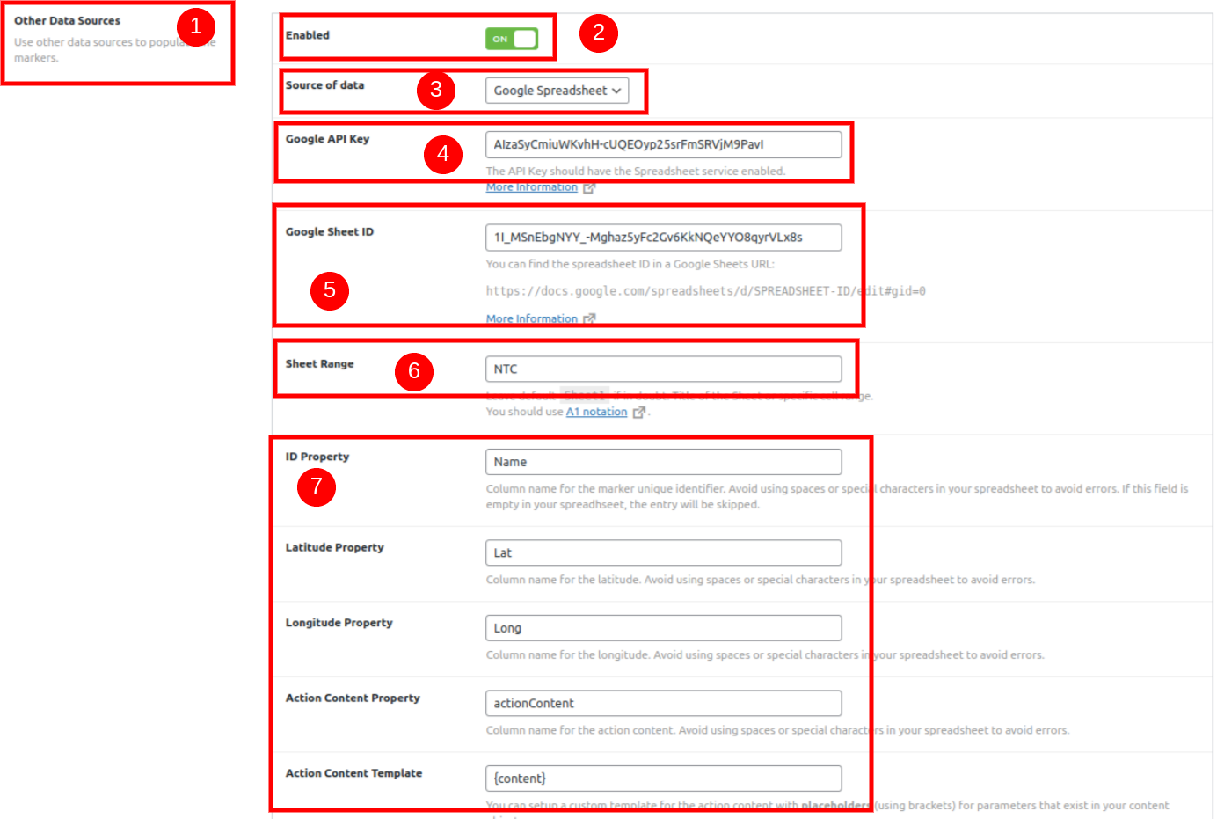

You can see this section round marker menu

1. Add marker from spreadsheet
2. Enable the option
3. Select source of data to google spreadsheet
4. Create a google API Key - <https://interactivegeomaps.com/docs/pro-populate-map-with-data-from-google-spreadsheet/>
5. Add spreadsheet id - you can see the spreadsheet id in the spreadsheet link [https://spreadsheets.google.com/feeds/list/{SPREADSHEET_ID_HERE}/od6/public/values?alt=json](https://spreadsheets.google.com/feeds/list/%7BSPREADSHEET_ID_HERE%7D/od6/public/values?alt=json)
6. Add sheet range name, at the bottom of the spreadsheet you can see the name   
   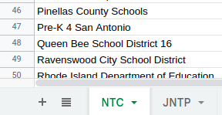
7. Add title from spreadsheet  
   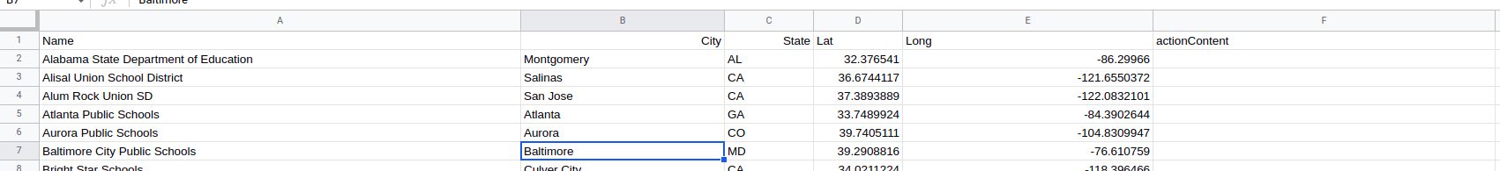

# Map FIlter

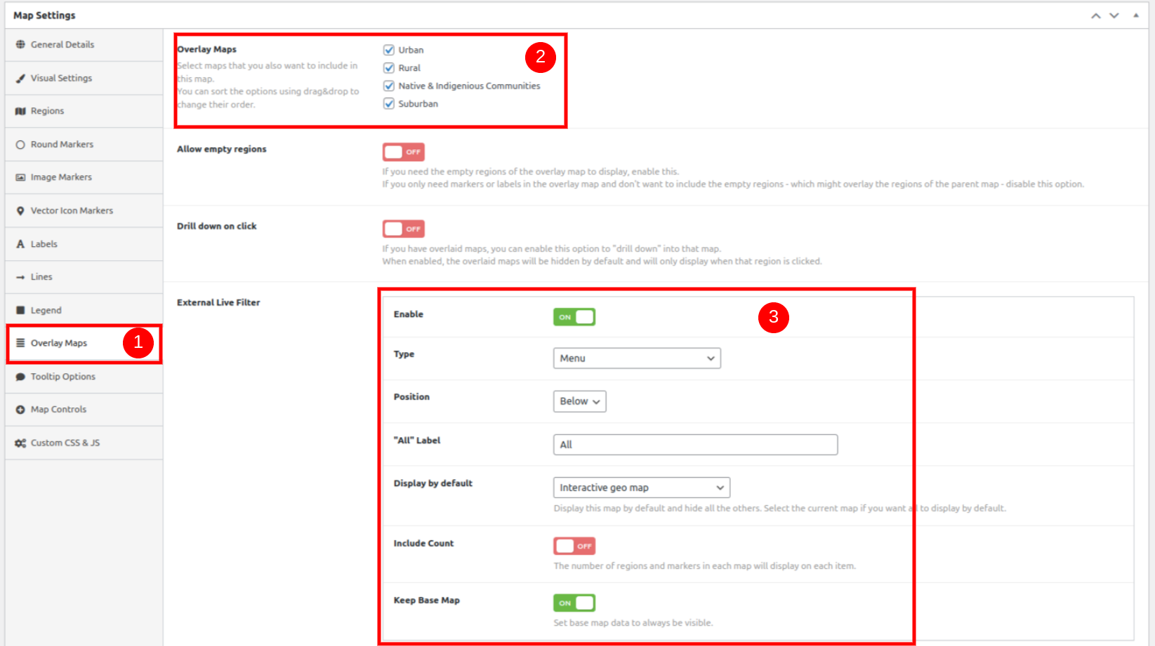

1. CLick on Overlay Maps on left hand side tab
2. Select map which you want to filter
3. Enable the live filter option and change settings as per need.

# Map Cusom CSS/JS

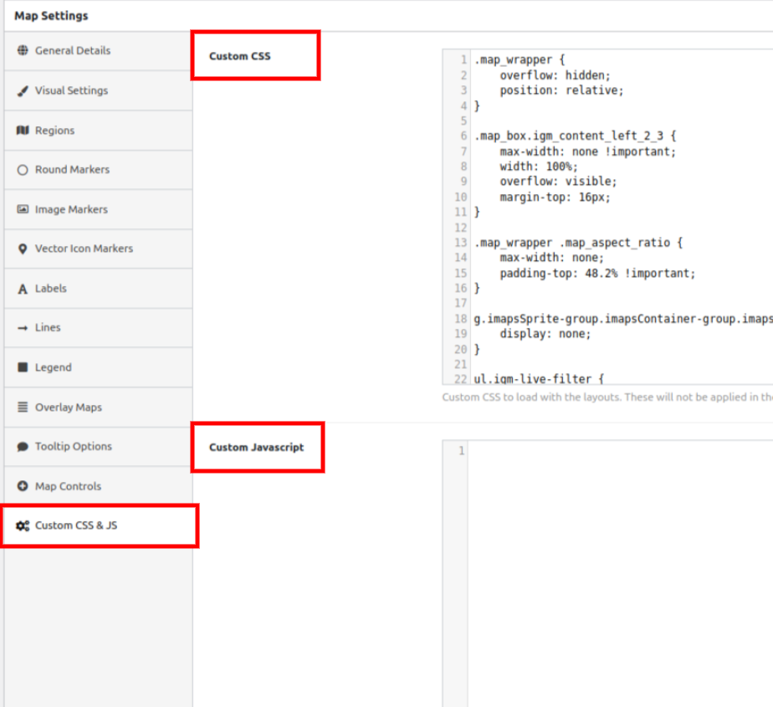

To add custom css/js

1. On Map Setting click on **Custom CSS & JS** to add custom style and js.

# Populate map from Custom Post Type

Use this url - <https://gist.github.com/carmoreira/1e23c1100828a3ea7ffc2cb7047c118a>